**Leesville Lake Association, Inc.**

**Spring General Membership Meeting – April 12, 2025**

**Location: Altavista Train Station – 10:30 AM**

1.      Call to Order – the meeting was called to order at 10:32 am. LLA Board members and officers attending were Roy Kelley, Chip Zimmerman, Edwin Hanson, Debra Kiraly, Teri Thomas, Cynthia Coleman, Glenn Coleman, Pam McMillian, Charlie Hamilton, Dave Waterman, Dannie Smith, Tom Galvanek and Jeff Markiewicz.

2.      Introductions – Roy Kelley asked the officers and Board members to introduce themselves and all members to introduce themselves. It was noted that refreshments were provided at the back of the room.

3.      Guest Speaker Introduction: Jeff Markiewicz introduced John Broughton – the Franklin County Building Official (CBO) who addressed Electrical Safety on Docks. Mr. Broughton is also Past President of the Virginia Building Code Association. Jeff described the incident on SML last year, wherein a young man lost his life after there was stray voltage from an improperly wired dock on the lake. This is currently a hot topic on the lake and was before Covid. They are trying to make it uniform across the counties, and note this is not just a Virginia problem, but also one where any docks are built on lakes. Electrical work on docks needs to be done correctly. It was determined in the case mentioned above that there was stray voltage from faulty wiring, and it also comes from utility companies. 6 Volts is the industry wide standard where it is life threatening. Most docks will test at about 2-4 Volts.

Mr. Broughton recommended that all electricity be turned off at the dock when you have swimmers in the water, and there should be an electrical shutoff at the dock or shoreline. Residential signage has been developed warning about the electrical hazards, and LLA will try to make those signs available for purchase. Floating sensors are also available to sense the presence of electricity in the water.

This is an issue where short-term rentals have been made on SML, but all docks are recommended to be checked at least every five (5) years. They need to be inspected by a licensed electrician who is familiar with marine electricity.

On the LLA website, we will make available a link to the presentation Mr. Broughton provided. LLA will also try to post links to the various county codes regarding stray voltage and correct electrical wiring for docks.

4.      Treasurer’s Report: Edwin Hanson -

March Treasurer’s Report: We saw income of $6,884 and expenses of $10,265. Income was primarily from Beautification Day Sponsors. Expenses were primarily from: Water Quality and accounting software.

VA SCC Registration: Our Corporate registration with the Virginia State Corporation Commission has been paid.

Internal Finance Review: The Finance committee completed our in-house financial review and has submitted its report to the Board. No discrepancies were noted.

FY 25-26 Budget: I will have the proposed budget prepared prior to the picnic, so we can approve it before the start of the fiscal year. A motion was made, seconded and all in favor approved the Treasurer’s report.

5.      Full Committee Reports:

a.      Executive - Roy Kelley – no report.

1.      Need Beautification Day Chair – we still need additional volunteers to help Roy.

  b.      Beautification Day –

i.      June 14, 2025 – need boats, chainsaws, and committed members.  Save the date. Drop off points will be Runaway Bay, Tri-County Marina and Leesville Lake Marina. The AEP barge will be primarily working the upper half of the lake, and those working the upper half of the lake will help feed the barge. Last year 55 tons of debris were removed, and we will always have more. The deadline for T-shirts is 30 May, and mid-May for sponsorship on the T-shirts. As in past years, we need people at each site, chain saws, chains, front-end loaders, and LLA is coordinating the dumpsters. Sign up on the LLA website.

*c.*       Vice President Update – Chip Zimmerman – no report.

*d.*      Communications Update – Dave Waterman – Leanne Hanson and Charlene Duckworth have volunteered to do the newsletter.

*e.*      Debris Update – Pam McMillan *-* *-*AEP called for its first regular monthly survey on April 1st. And as usual, they invited LLA to participate. We have yet to receive AEP’s report to compare their findings to ours.

However, our committee found the lake in very good condition. Committee member Rob Johnson surveyed the lower miles 0-8 and observed at that time that there was very little debris in the main channel and not much on the shorelines.

Gary and I did the upper half of the lake and observed most of the main channel was clear of debris and only an occasional log or small areas of mulch like material were present. The shoreline held most of the debris and even that was minimal.

We had no high flow triggers in the month of March or April, so we are starting the collection season out with a much better canvas compared to last year’s start of the recreational season.

-AEP also called for its Annual Technical Review Committee meeting at the end of this month to discuss with TLAC and the LLADC its overall plans going forward for 2025.

Most importantly, we hope to hear a positive update on the application permit process and where we might stand on the Pigg River barrier project. It will be nearly a year since Appalachian submitted these permits.

-Until we receive AEP’s first survey report we have no information on how much they worked or how many tons were collected in March.

TLAC had informed us that 15 reports were processed from LLA Members for the month of March, and we really appreciate those who put them in, thank you.

-And finally, if you haven’t read our April newsletter yet, our committee submitted our comments of critique, recommendations and gratitude included in Appalachian’s 2024 Annual FERC report. You can read this in full on our website.

Also, we now have a new committee member, Tom Galvanek, who has stepped up to help us out on the Debris committee. Tom will be available on a part-time basis and so we are grateful for any help we can get to fill in. Thank you, Tom.

We could still use some extra hands so let us know if you’re interested.

Pam noted that a resident in Runaway Bay had damage to their dock from debris, and this was reported.

f.        Membership Update – Cynthia Coleman – Cynthia reported that we have 203 households as members. Cynthia described the raffle items that were available at today’s meeting, which were LVL caps. These ball caps, as well as LVL bucket hats will be sold at the Annual Picnic. Sixteen were bought at the April meeting for $15. The bucket caps will be sold at around $25.

Raffle tickets were drawn, and the winners were Margaret Bennett and J. W. Burton.

g.      Navigation Update – Glenn Coleman – Glenn reported that the pontoon boat is ready to be put in the water on Monday. There needs to be repairs to Mile Marker(s) 15 and 16, there are currently two (2) Mile Marker 13’s and Dannie Smith replanted Mile Marker #8.

h.      Nomination Update – Teri Thomas - Welcome to the board’s newest director, Tom Galvanek. Tom expressed interest in serving on the Debris committee and Beautification Day committee. With respect to Calendars:

· 89 sold as of April 12th - $1111 total minus $890.57 costs = $220.43 profit

· 41 available – will be available at the Annual Picnic/General Meeting

i.        Secretary – Debra Kiraly – The minutes for the LLA Board meeting of March 13, 2025, were completed. A motion was made, seconded and the minutes were approved.

j.        Water Safety Update – Jeff Markiewicz – The 2025 Vessel Safety Check season will start in late April or May after the Safety Examiners complete training on rules changes for 2025. Jeff will continue to be available to perform vessel safety checks by request starting in ate April or May and looking to have mor opportunities to perform checks on Leesville Lake in the 2025 season. Currently planning to have Vessel Safety Checks at the Leesville Lake Marina and Grill on May 17th, and at the July Picnic/Membership appreciation day – July 12th. Jeff will be approaching Tri County Marina for a potential date for checks as well.

Boater Safety Classes – The Boater Safety in person class season is starting soon, below are the upcoming classes available on the DWR registration site. The LVL Association continues to leverage training provided from the VA Dept. of Wildlife resources, US Coast Guard Auxiliary, and the Local Power Squadron (now known as America’s Boating Club). Jeff encourages all LVL members to take advantage of these courses, some of which are free of charge.

Continue to refer to VA DWR:

1. Upcoming Classes from the DWR website – link is on the LLA Website on Water Safety Committee, and under resources, Boating Safety
2. Sat. April 26, May 20, June 14 and July 26, 8:00-4:00 pm, Bethlehem United Methodist Church, 13586 Old Moneta Rd., Moneta VA 24121. $40 fee due at class, Contact is Randy Stow – 540-588-0270
3. Mon, April 14 and Tuesday April 15, 6:00-9:00 pm, 1501 Lakeside Drive, University of Lynchburg, Rm HOBB 312, Lynchburg, VA 24501
4. Tuesday April 22 and 29, Thursday April 24 and May 1 6:00-8:30 pm Virtual class, must have own device/computer, free course, contact Trevor Ruble – [trevor.ruble@dwr.virginia.gov](mailto:trevor.ruble@dwr.virginia.gov)
5. Mon, July 7, July 14, Tues. July 18 and 15, Thurs. 6:00-8:30 pm Virtual class, must have own device/computer, free course, contact Trevor Ruble – [trevor.ruble@dwr.virginai.gov](mailto:trevor.ruble@dwr.virginai.gov)
6. On-line Courses – Virginia Boating Safety <http://www.boat-ed.com/virginia/>
7. America’s Boating Course – <http://www.americasboatingcourse.com/>
8. Other Boating Classes – The SML Sail and Power Squadron (the closest US Power Squadron, now referred to as America’s Boating Club) provides classes, especially a hands-on training class. It is a daylong class including classroom instruction and hands-on training on the owner’s boat. Not eh boat must have a current Vessel Safety Check. The class is free to Power Squadron Members – Family Membership is approx. $110 per year. The cost of hands-on training is $180.00 for non-members. SML Sail and Power Squadron also offer other classroom and practical training ( e.g. Mechanical and Electrical systems, Boat handling and navigation classes. These are free to SML Squadron members. Contact Jeff at [safety@leesvillelake.org](mailto:safety@leesvillelake.org) for more information on Squadron membership.
9. DWR 2024 boating incident summary report – Based on a review of 2021, 2022, 2023 and 2024, Virginia DWR boater incident safety summary reports that there were no reported incidents on Leesville Lake in those years. Also of the 17 fatalities last year, 35% were on paddle craft (canoes and Kayaks) and 94% were not wearing a life jacket. During three of those years, SML had the highest number of incidents in Virginia. In 2024, SML had a dramatic improvement to less than half the prior three-year average (20 average to 9 in 2024.
10. Based on the information from SML Association Water Safety Council, that Jeff is also a member of, it is noted that there are some limitations to the Date in Annual Water incident reports. An example of this is that deaths from drowning from falling from a dock or shoreline are not included in VA DWR’s jurisdiction and are reported separately by the local law enforcement and the State Police. The SML Water Safety Council is looking into getting more updated information.

k.       Water Quality Update – Charlie Hamilton- - Leesville Lake Water Quality is currently good. Our Leesville Lake 2025 sampling starts this month and will continue through September 2025. It has been funded by APCo ($39,095.00).

LLA submitted its 2024 Annual WQ Report on 28 February 2025, with issues tied to the Mouth of Pigg River, Toler Bridge, SM Dam tailwater release. This is posted on LLA website.

LLA submitted its comments on the APCo 2024 WQ Report on 3/28/2025, highlighting Dissolved Oxygen concerns between July and October 2024, and recommending a forebay oxygen line diffuser (used by Georgia Power on the Wallace Dam) as a DO solution. A WQ TRC has been scheduled 1-3 PM Wednesday 30 April 2025.

LLA submitted its Public Comments on the Smith Mountain Lake Draft Project 24-1547 Permit, highlighting concerns with Dissolved Oxygen, and recommending a time phased requirement for the Permittee to achieve year-round dissolved oxygen standards.

LLA 2025 Pigg River Water Monitoring Plan also starts in April 2025.

2025 Focus is quantifying Bacterial load in the water flowing in LVL from the Pigg River through 10 sampling events

TLAC has funded this effort ($8730.16).

Balico Project - LLA has been monitoring the Balico Project (pending Pittsylvania County Data Center project) for any impacts on LVL water quality. (Rezoning 750 acres, 12 data centers (expandable to 84), a 300-megawatt mobile power plant, with expansion to 3500 megawatts, extraction of 2 million gallons of water per day from Hurt, Va; APCo reports no impact to their operating permit by downstream water removals).

Balico goes before the Pittsylvania County Board of Supervisors on April 15, 2025

Pittsylvania County Planning Commission recommended denial of the rezoning request to the Board of Supervisors.

 6.      TLAC Updates - Charlie Hamilton (attended for Roy Kelley) TLAC 8 April 2025

Summary:

Elections (all approved):

1. April 8, 2025, Consideration of Appointment of Leesville Lake Association (LLA) Representative

TLAC Board of Directors to appoint the LLA Representative annually. Staff requests that LLA President, Roy Kelley be reappointed for 2025. This appointment will be through January 31, 2026.

2. April 8,2025 Consideration of Appointment of Environmental Committee and Chairman - Leesville Lake (LVL) TLAC Board of Directors to appoint the LVL Environmental Committee members annually. Appointments will be through January 31, 2026.

Charlie Hamilton (Chairman), Dave Waterman

3. April 8, 2025, Consideration of Appointment of Navigation Committee and Chairman - Leesville Lake (LVL) TLAC Board of Directors to appoint the LVL Navigation Committee members

Glenn Coleman (Chairman) Joe Humphrey, Dick Grabowski and Gary Dalton.

Wake Education Update

Below is purported to be our (LLA) final recommended safe towed watersports operating area.

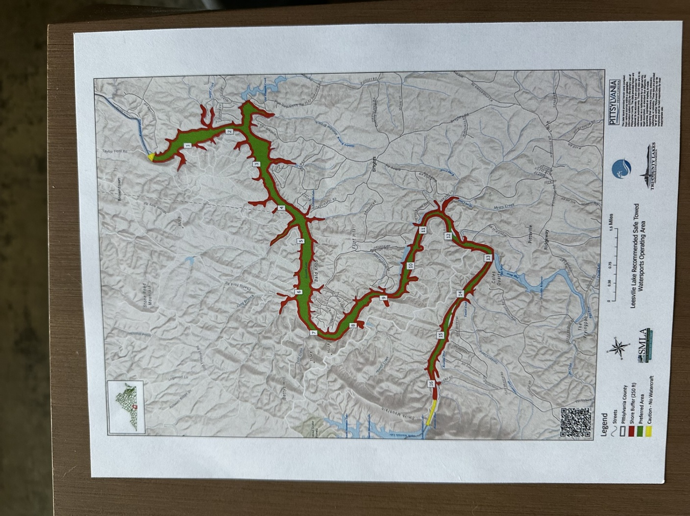

LLA report - APCo had two reps at the meeting (temporary replacements for Neil Holtshauser who took a city position in Galax, Va) Brian Ellinwood, and Brannon Littleton. Brannon reports that the Army Corps of Engineers has pulled the Debris Diversion Device application in order to do a navigational study (sometime in 2026). This will delay the timeline for installation by at least a year. I asked for the Army Corps of Engineers letter of determination.

APCo received notification of the Joint Permit Application (JPA) withdrawal not via letter, but with an internal email from USACE staff to the AEP Environmental Manager who has been assisting with the permit process.

On January 27th, 2025, APCo received a request from USACE to conduct a navigational study to evaluate the impact of the project to navigation on the Pigg River. On February 25th APCo received the notification email informing us that the JPA would be administratively withdrawn effective February 27th.

APCo will develop a more detailed communication concerning the status of the Pigg River Debris project and share that with LLA and others in the coming weeks.

APCo report

APCo reports the new Shoreline Management Plan is now posted on their website.

Next meeting June 10th 4PM.

Neil Holthouser (APCo Shoreline Management) has resigned.  No named replacement.

7.      Old Business

8.      New Business

a.      General Membership Meeting – next meeting is scheduled for July 12th, 2025, for our annual Beautification Day Appreciation luncheon.  Expect it to be at the Lake Leesville Marina.

b.      But, before that… See you all June 14th for our Beautification Day Lake cleanup!

9.      Q&A for members

The meeting was adjourned at 12:34 pm.

